# Extract Images from PDF Documents in Python

[[Alex Stock](https://medium.com/@alexaae9?source=post_page-----9492a767a613--------------------------------)](https://medium.com/@alexaae9?source=post_page-----9492a767a613--------------------------------)

[Alex Stock](https://medium.com/@alexaae9?source=post_page-----9492a767a613--------------------------------)

·

[Follow](https://medium.com/m/signin?actionUrl=https%3A%2F%2Fmedium.com%2F_%2Fsubscribe%2Fuser%2F3660c89a71b&operation=register&redirect=https%3A%2F%2Fmedium.com%2F%40alexaae9%2Fpython-how-to-extract-images-from-pdf-documents-9492a767a613&user=Alex+Stock&userId=3660c89a71b&source=post_page-3660c89a71b----9492a767a613---------------------post_header-----------)

3 min read

·

Oct 12

14

Extracting images from a PDF file can be a useful and practical task in various situations. Whether you need to repurpose images for a presentation, create a digital photo album, or simply save images for future reference, the ability to extract images from a PDF can save you time and effort. In this article, you will learn how to **extract images from a PDF document in Python** using [Spire.PDF for Python](https://www.e-iceblue.com/Introduce/pdf-for-python.html).

* Extract Images from a Specific Page in Python
* Extract All Images from a PDF Document in Python

## ****Install Dependency****

This solution requires Spire.PDF for Python to be installed as the dependency, which is a Python library for reading, creating and manipulating PDF documents in a Python program. You can install Spire.PDF for Python by executing the following pip command.

pip install Spire.PDF

## ****Extract Images from a Specific Page in Python****

Spire.PDF for Python offers the **PdfPageBase.ExtractImages()** method to extract images from a specified page. The following are the detailed steps.

* Create a **PdfDocument** object.
* Load a PDF document using **PdfDocument.LoadFromFile()**method.
* Get a particular page through **PdfDocument.Pages[index]**property.
* Extract images from the page using **PdfPageBase.ExtractImages()**method and return a list of images.
* Write each image in the list as a PNG file.

from spire.pdf.common import *  
from spire.pdf import *  
  
# Create a PdfDocument object  
doc = PdfDocument()  
  
# Load a PDF document  
doc.LoadFromFile('C:/Users/Administrator/Desktop/input.pdf')  
  
# Get a specific page  
page = doc.Pages[1]  
  
# Extract images from the page  
images = []  
for image in page.ExtractImages():  
 images.append(image)  
  
# Save images to specified location with specified format extension  
index = 0  
for image in images:  
 imageFileName = 'C:/Users/Administrator/Desktop/Extracted/Image-{0:d}.png'.format(index)  
 index += 1  
 image.Save(imageFileName, ImageFormat.get_Png())  
doc.Close()

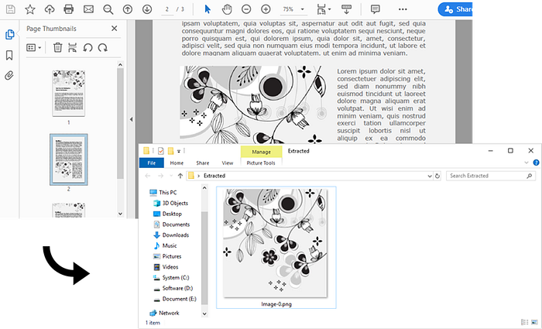

## ****Extract All Images from a PDF Document in Python****

To extract all images from an entire PDF document, loop through the pages in the document and then retrieve the images from each page separately. Here are the detailed steps.

* Create a **PdfDocument** object.
* Load a PDF document using **PdfDocument.LoadFromFile()**method.
* Iterate through the pages in the document, and get the images from each page using **PdfPageBase.ExtractImages()** method.
* Write all extracted images as individual PNG files.

from spire.pdf.common import *  
from spire.pdf import *  
  
# Create a PdfDocument object  
doc = PdfDocument()  
  
# Load a PDF document  
doc.LoadFromFile('C:/Users/Administrator/Desktop/input.pdf')  
   
images = []  
  
# Loop through the pages in the document  
for i in range(doc.Pages.Count):  
 page = doc.Pages.get_Item(i)  
  
 # Extract images from a specific page  
 for image in page.ExtractImages():  
 images.append(image)  
  
# Save images to specified location with specified format extension  
index = 0  
for image in images:  
 imageFileName = 'C:/Users/Administrator/Desktop/Extracted/Image-{0:d}.png'.format(index)  
 index += 1  
 image.Save(imageFileName, ImageFormat.get_Png())  
doc.Close()

